

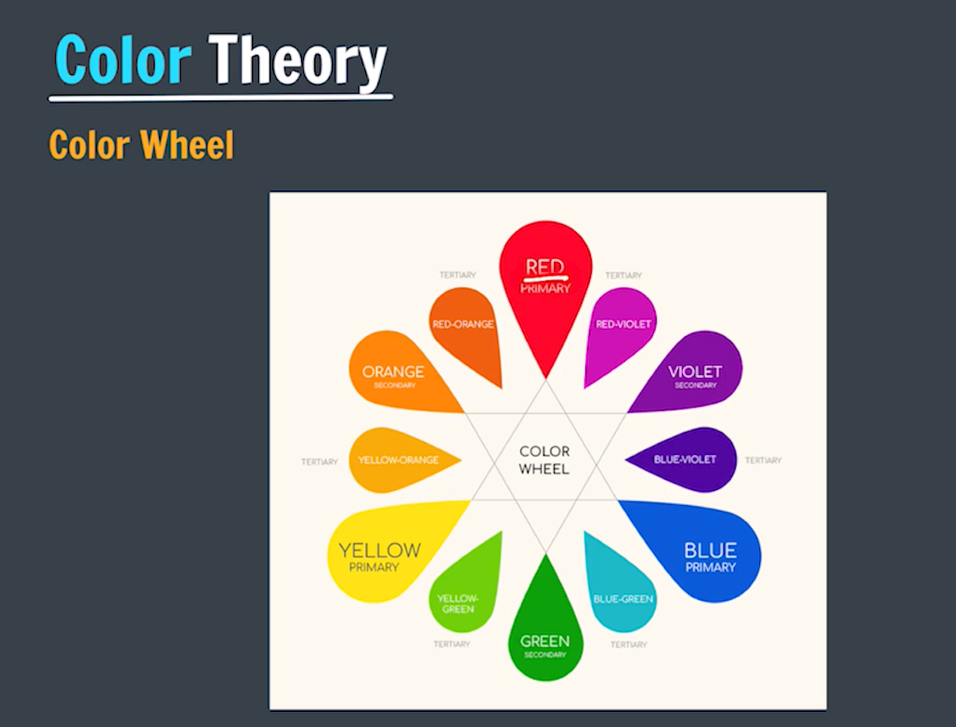

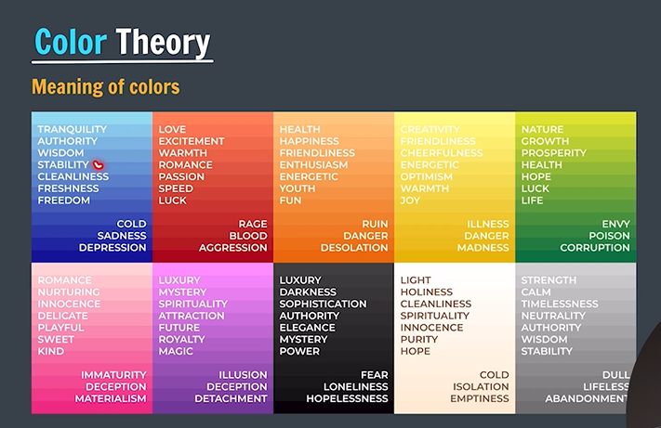





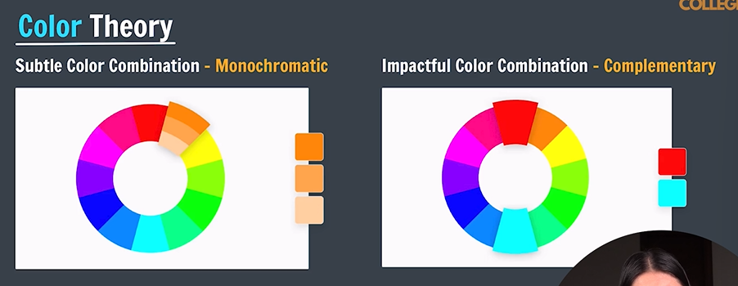

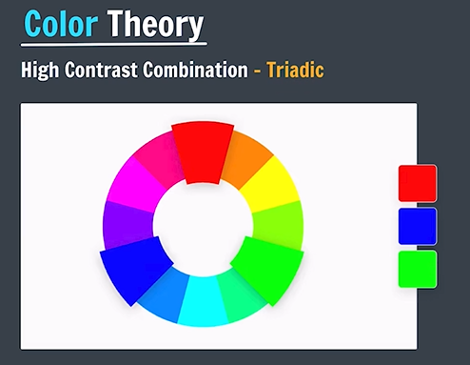

For More Information: <https://www.canva.com/colors/color-wheel/>

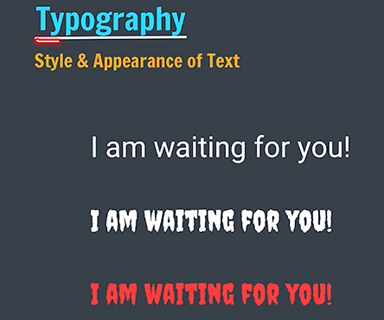

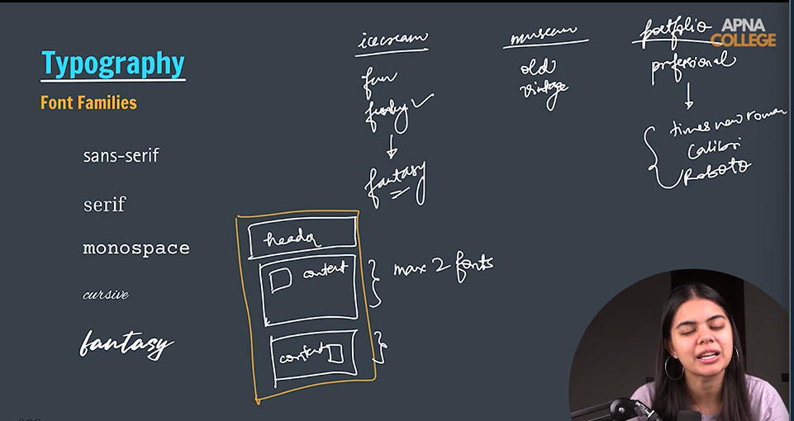



Library of fonts (1513 fonts) / free (google fonts): <https://fonts.google.com>

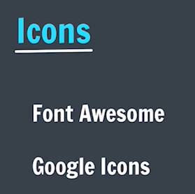

Google Icons: <https://fonts.google.com/icons>

Font Awesome: <https://fontawesome.com/icons>

Use Font Awesome Icon with link: [font-awesome - Libraries - cdnjs - The #1 free and open source CDN built to make life easier for developers](https://cdnjs.com/libraries/font-awesome)

Initially add link in html file in header tag.

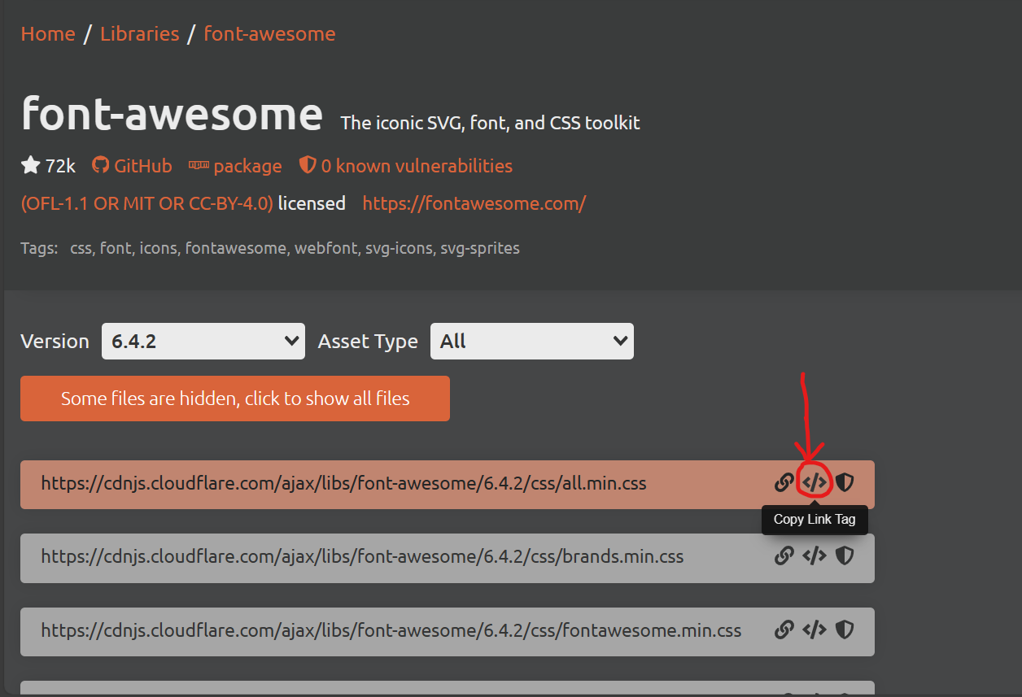

Paste in HTML file.



Select icon in font awesome and copy icon code.

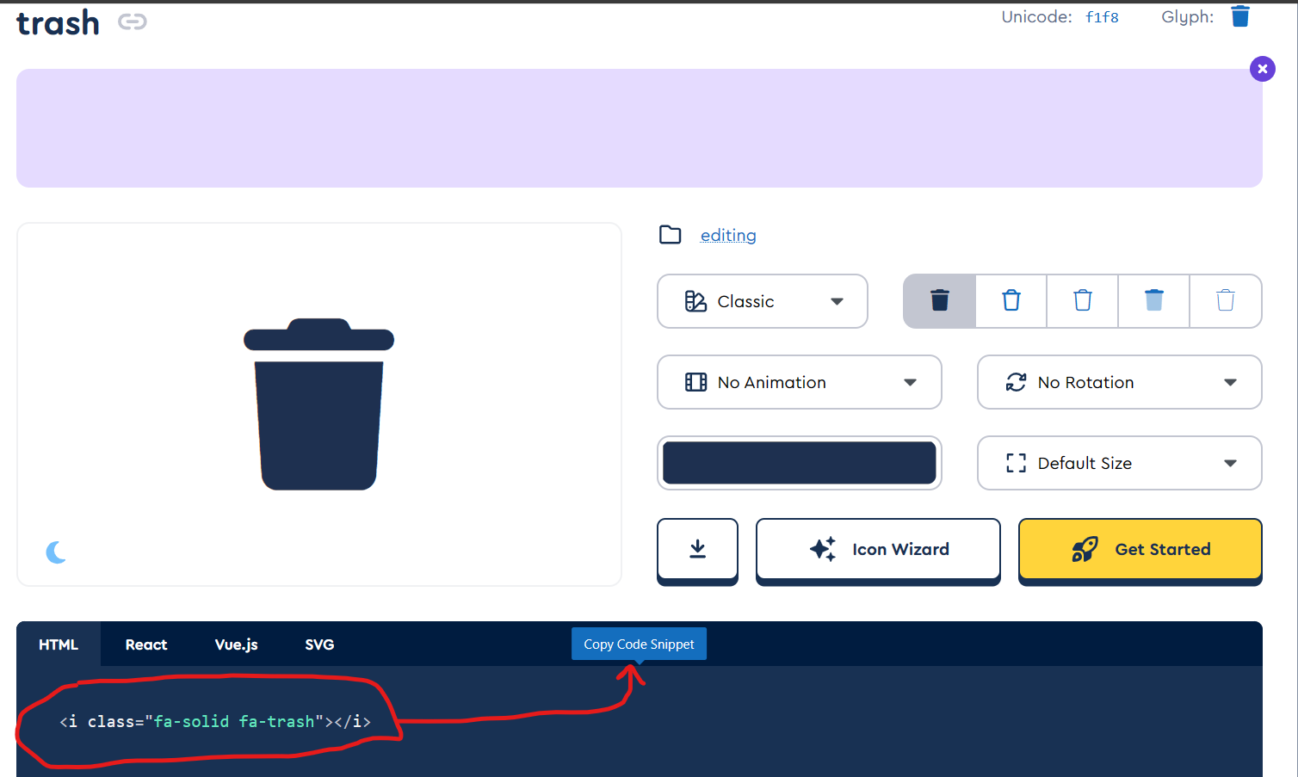

Paste in HTML file

